*Sent to all Members*  
  
September 9, 2024  
  
Dear {%FName%},

Rotary Minutes are provided by District 6220 Governor Roger Utnehmer (Oot-name-er). Please distribute in club newsletters and social media.

===========================================================  
  
“This is a Rotary Minute from District Governor Roger Utnehmer (Oot-name-er).  
  
WHY ROTARY SOMETIMES SOUNDS LIKE IT’S ABOUT THE MONEY?

I’ve asked a risky question, “Why should I avoid talking about this as District Governor when visiting clubs throughout the district?”

The most-mentioned response was, “Don’t make it about the money.” I was also advised to be brief.

Yet, after considering valued input, I owe you an explanation why it is absolutely essential to include some discussion about money.

If Rotary International were a business, our product would be service.

We serve in seven specific areas:

…polio eradication and disease prevention

…women and children

…economic and community development

… environment protection

…education and literacy programs

…fostering peace and resolving conflict

…water and sanitation

And it requires the generosity of those who donate to the Rotary Foundation to fund the services provided in these seven areas.

“When Rotary gave us this well, our children stopped dying.” Mother in Haiti

“If everyone could be a Rotary Youth exchange student there would be no war.” Swedish High School Exchange student

“Downtown Eagle River is better today because of the park with restrooms that we made possible.” Eagle River Rotarian

“Our water is drinkable because Rotary cleaned up this river.” Government official in Nicaragua

“I’m working for the United Nations because Rotary gave me a global scholarship grant to study peace and conflict resolution.” UN employee

Because of these people and what Rotary has meant to their lives, I’ll keep asking, but always with respect for individual circumstances and timing.

Without financial support, it’s a lot more challenging to do good things.

The impressive support from Rotarians throughout District 6220 for the Rotary Foundation is truly GOOD NEWS.

And for that, I say “thank you.”

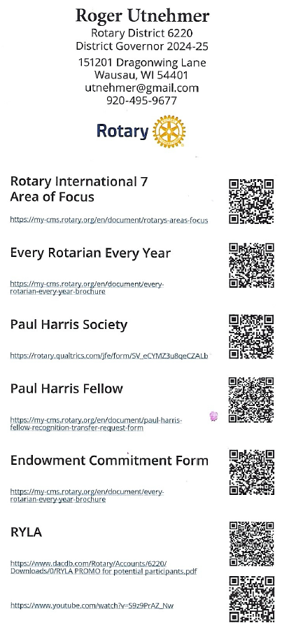

Thank you.  This has been a Rotary Minute.”  
  
Roger Utnehmer    
Rotary District 6220 PHS Coordinator   
District Governor 2024-25   
(C) 920 495 9677   
[utnehmer@gmail.com](mailto:utnehmer@gmail.com)